SCA — Software Composition Analysis

SCA scans the third-party libraries/dependencies used by our application and checks whether they contain known security vulnerabilities.
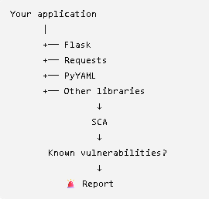
SAST → Is MY CODE insecure?
DAST → Is MY RUNNING APP insecure?
SCA → Are MY DEPENDENCIES insecure?

####

letslearn207/python-app-sast-demo

Create requirements.txt
In your project, create:
requirements.txt
Inside the file put:
Flask==2.2.2

Step 2 — Enable Dependabot
Create:
.github/dependabot.yml

version: 2
updates:
- package-ecosystem: "pip"
directory: "/"
schedule:
interval: "daily"
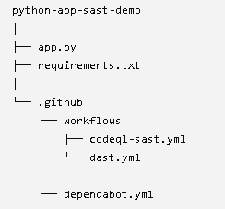

What does Dependabot do?
GitHub now knows:
Application
↓
requirements.txt
↓
Flask==2.2.2
Dependabot checks the dependency against GitHub's vulnerability information.
Conceptually:
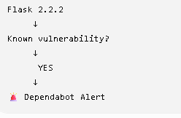
Step 4 — See the SCA report
Go to your repository:
Security and quality
Then look for:
Dependabot
or:
Dependency graph → Dependabot
If GitHub identifies a vulnerable dependency, you'll see an alert similar to:
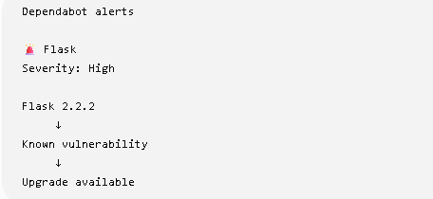

Go to repo settings -> enable Dependabot

